**ICP4 Assignment**

**Name :** Barla Srujana

**ID :** 16322539

Class ID : 6

**Goal of Assignment :**

The main aspect of the assignment is to learn and understand object-oriented javaScript with jQuery. To write the basic coding part of javaScript and built the web-application.

Below are the screenshots for the both the tasks:

Task-1:

1)In this, the empty background frame needs to show the images we hover on. Once the mouse pointer shows an image in the web page, that should be reflected. In this task, basically HTML, javascript and CSS need to used.

Below are the supporting screenshots for the same:

**HTML Code :**

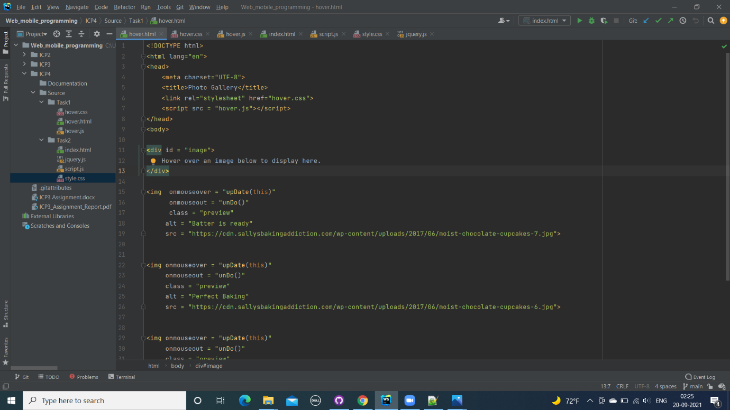

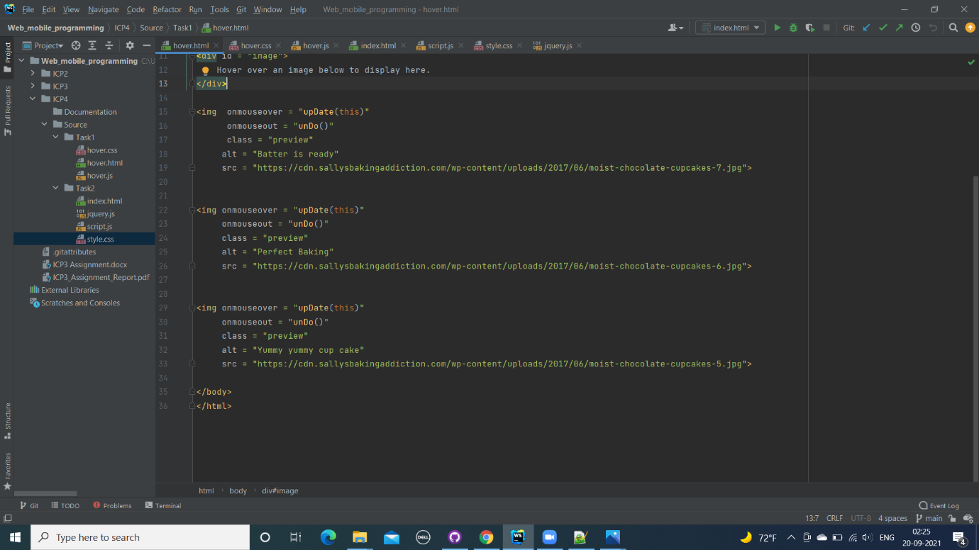

**CSS Code :**

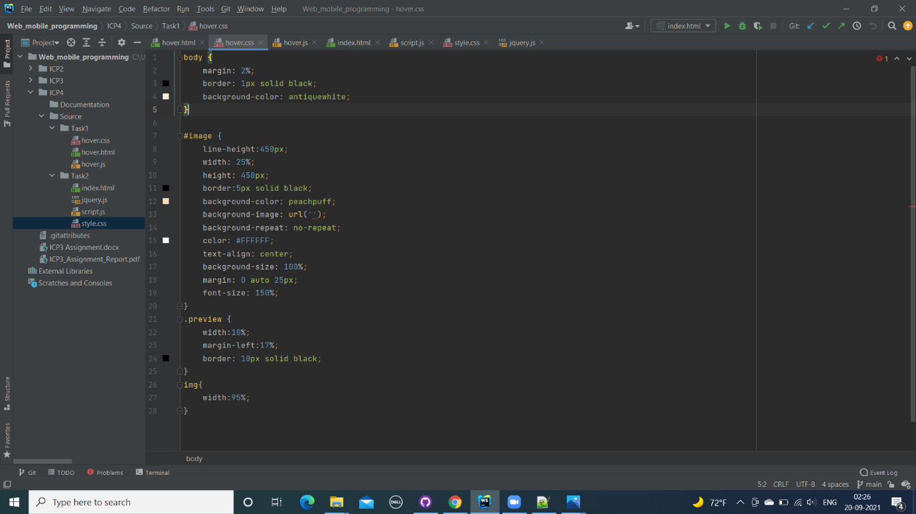

**JavaScript Code :**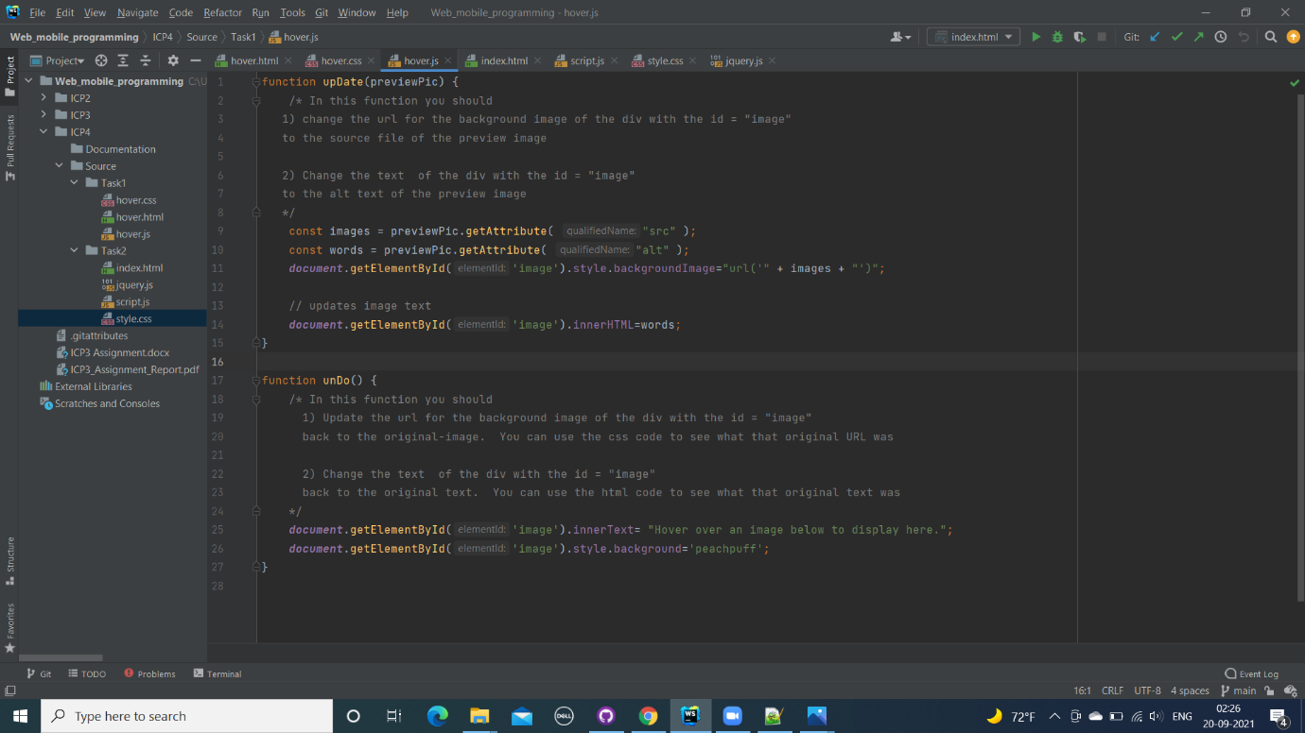

**Results of the Task1**:

As you move the mouse cursor, it shows the images on the frame in the centre.

Below image is shown , as soon as web page is opened.

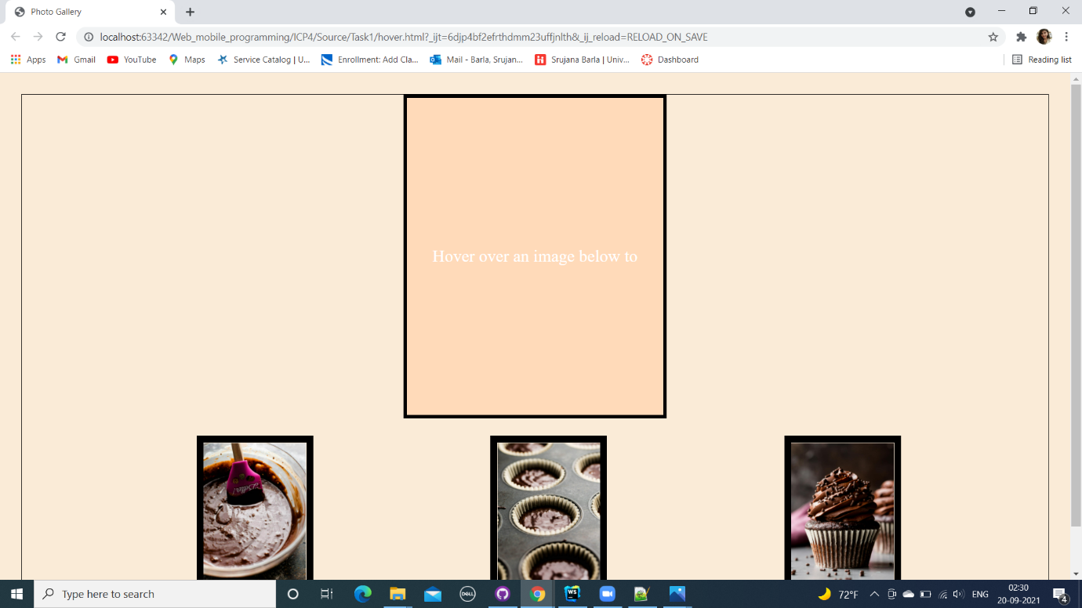

Once, we hover the cursor on one of the images below. Like here in the below image, mouse is on “batter is ready” image

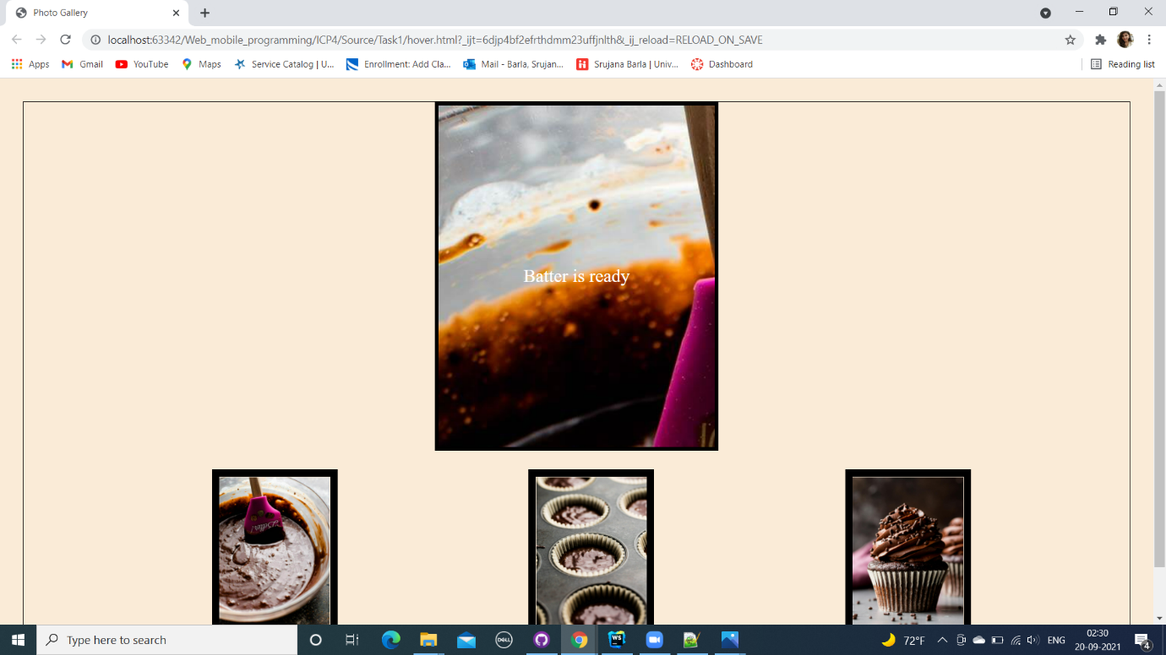

When cursor is hovered on the “perfect baking” image, it looks like below screenshot:

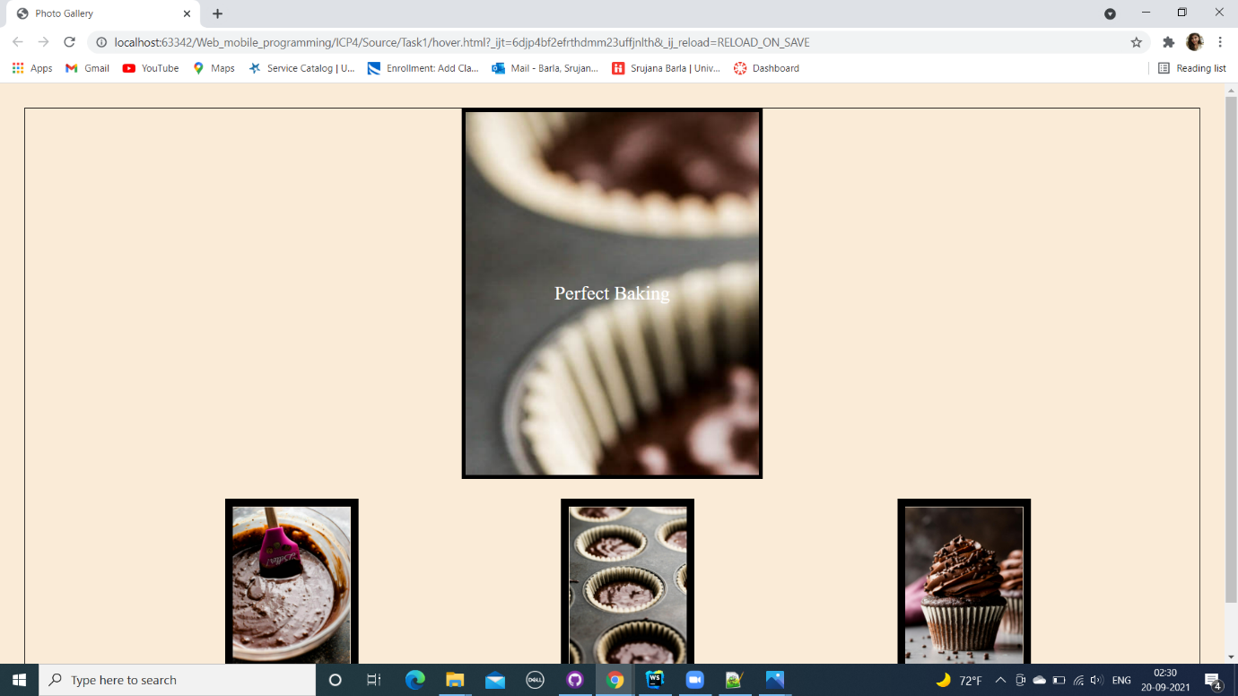

When cursor is on the “yummy yummy cup cake” image looks :

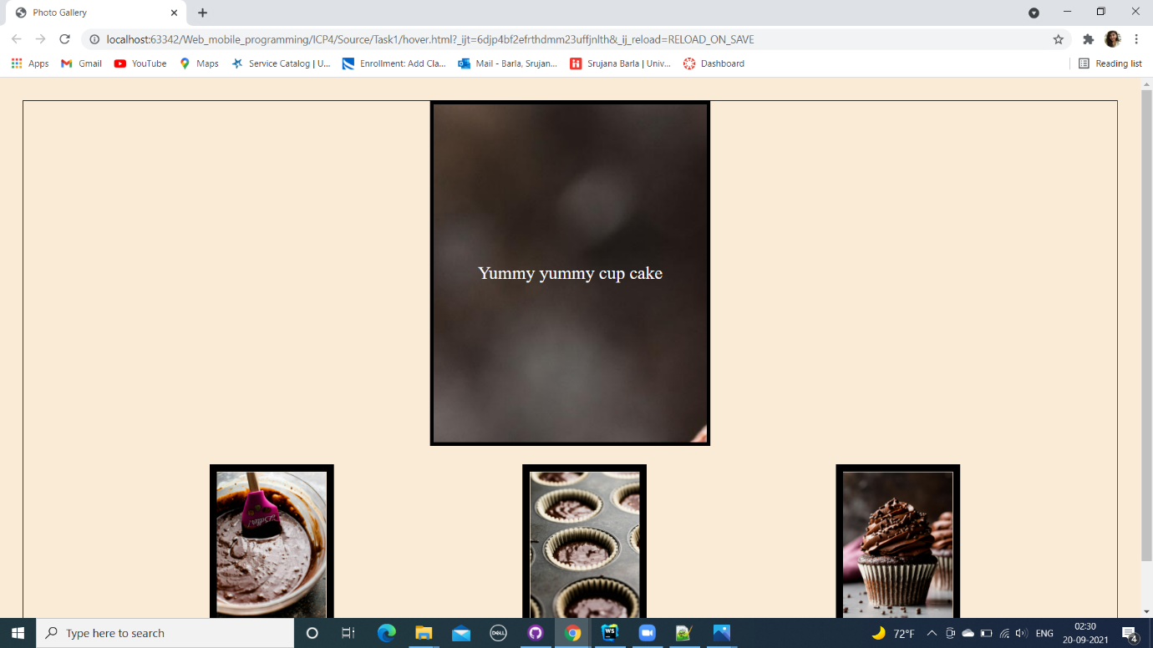

**Task-2:**

**2)**This task basically requires, profile vision of GitHub user. In this, when a username is entered on the search bar, it should show the details of the user. This need HTML, CSS, JavaScript, JQuery coding.

Below are the screenshots for the same.

**HTML Code:** 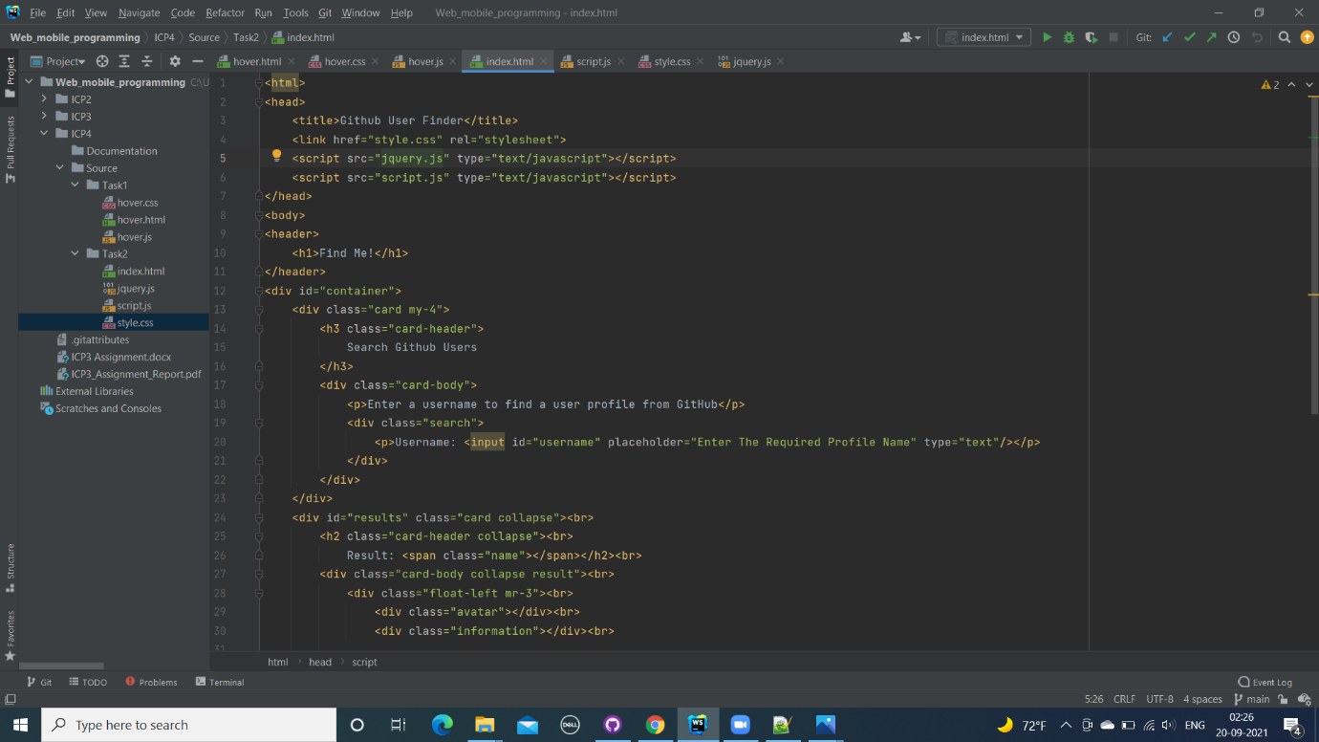

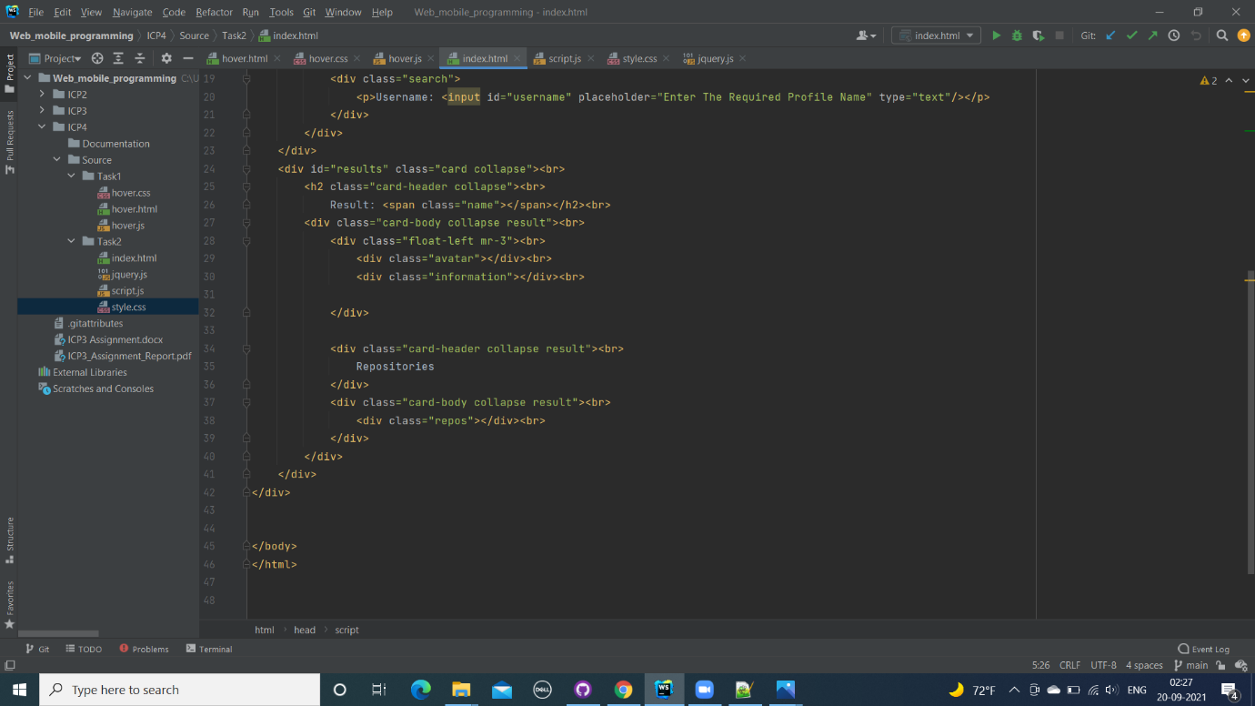

**JavaScript Code:**

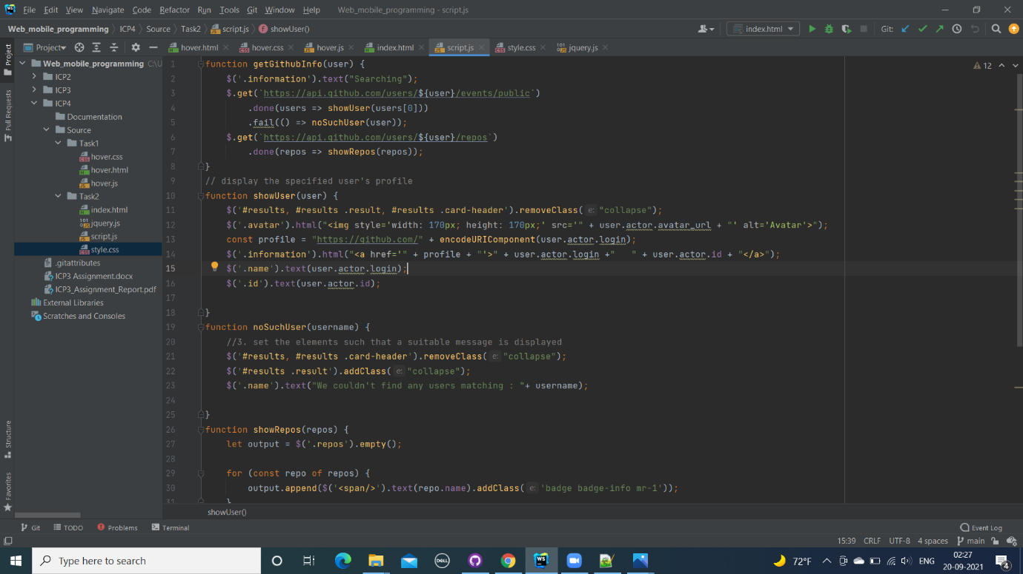

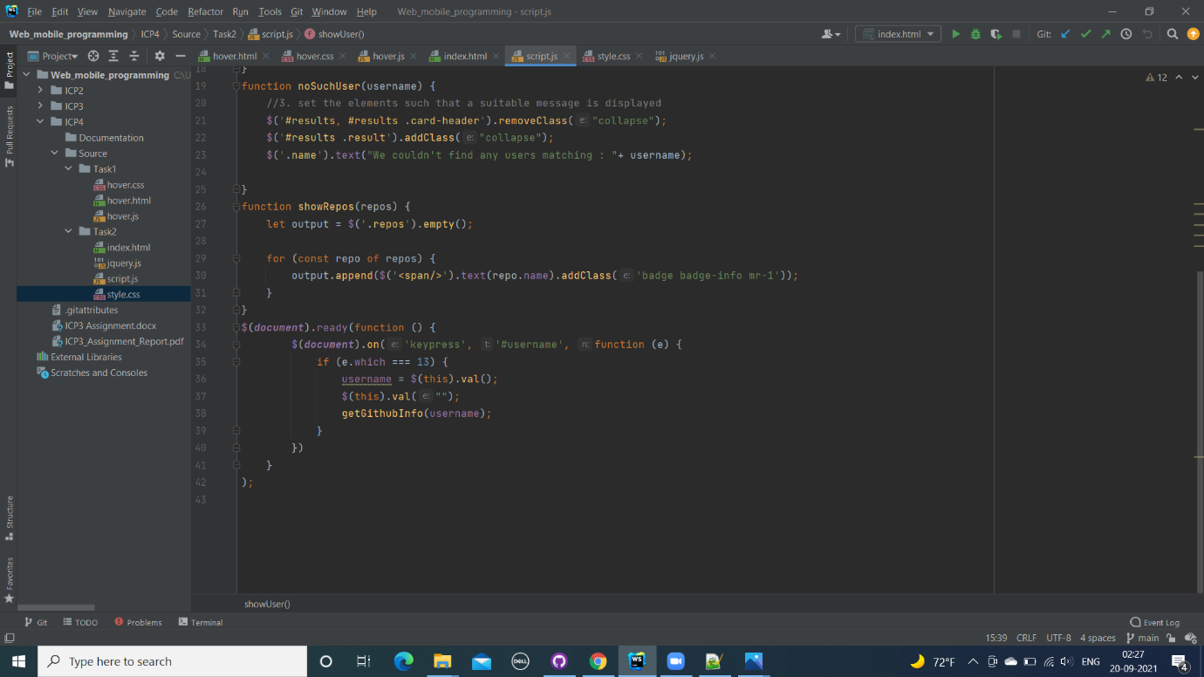

**CSS Code:**

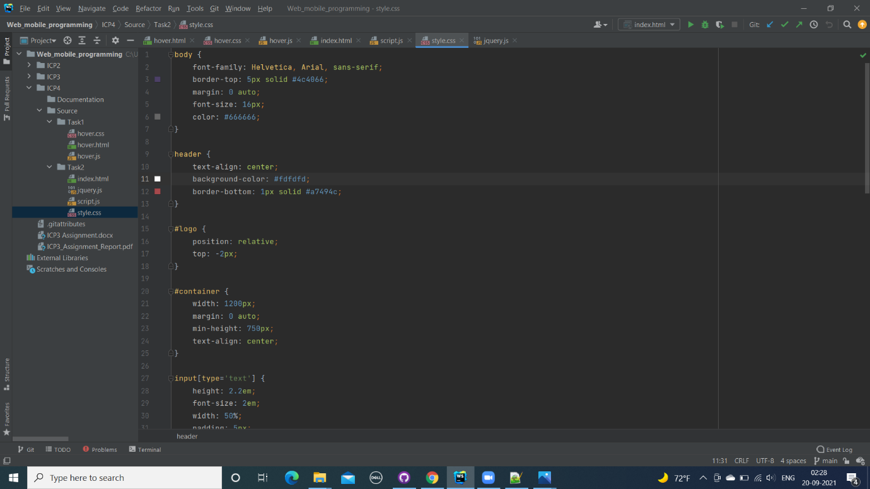

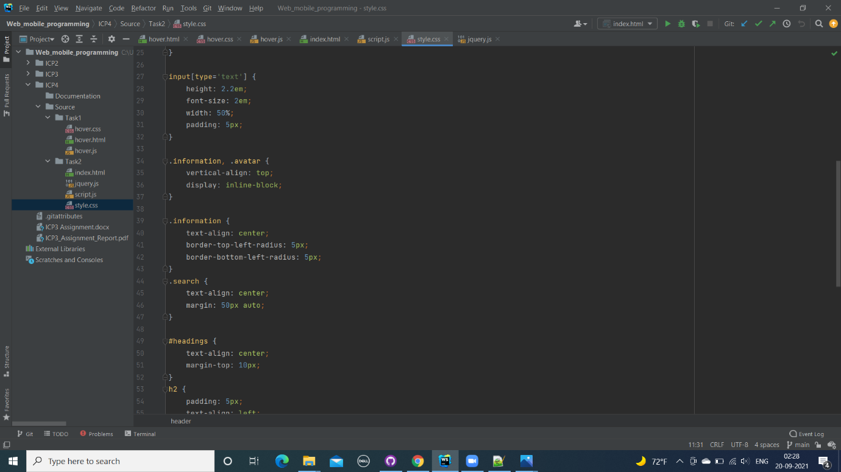 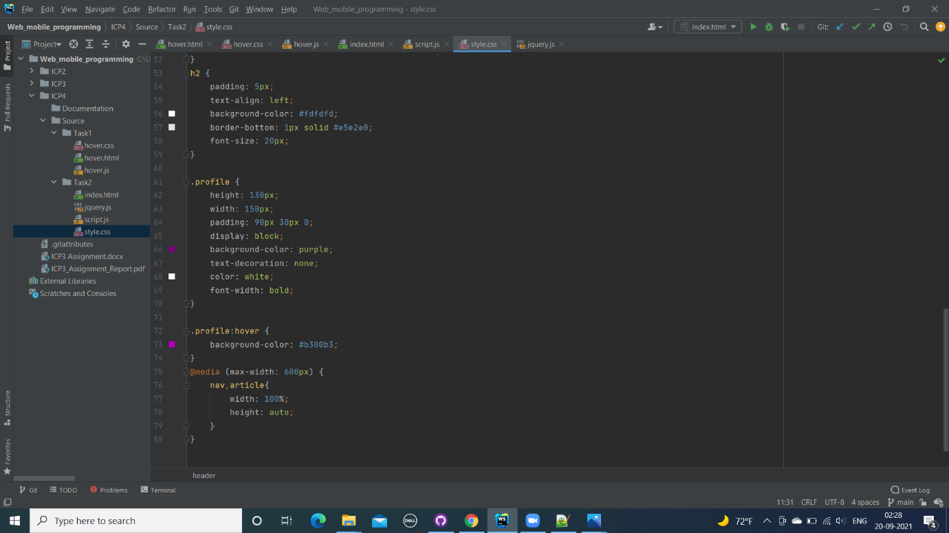 **JQuery Code:**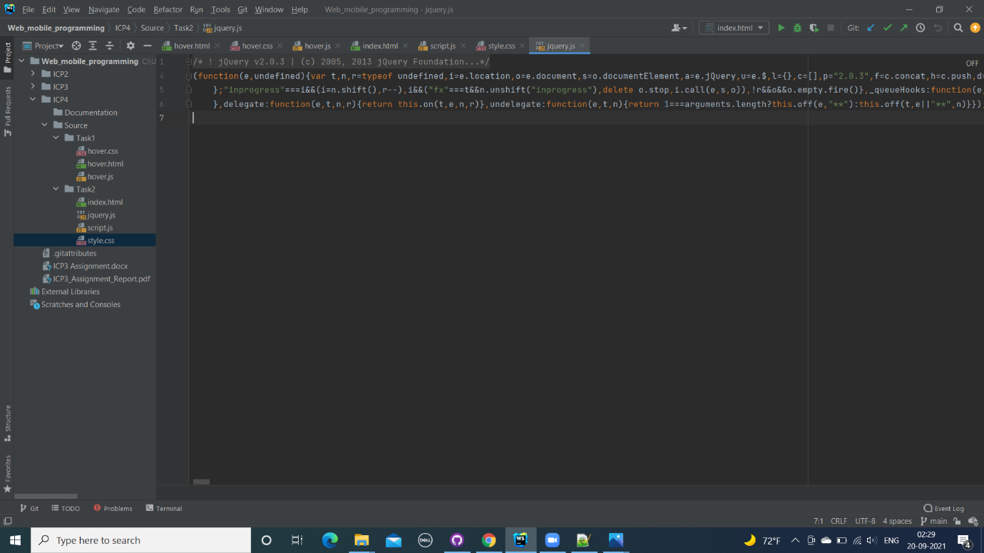

**Below are the snippets for the Task-2 :**

As soon as web page is launched , it looks like below screenshot, with a slight boader lines near “ Find Me”, below with an Username search box and the result section for the user details one.

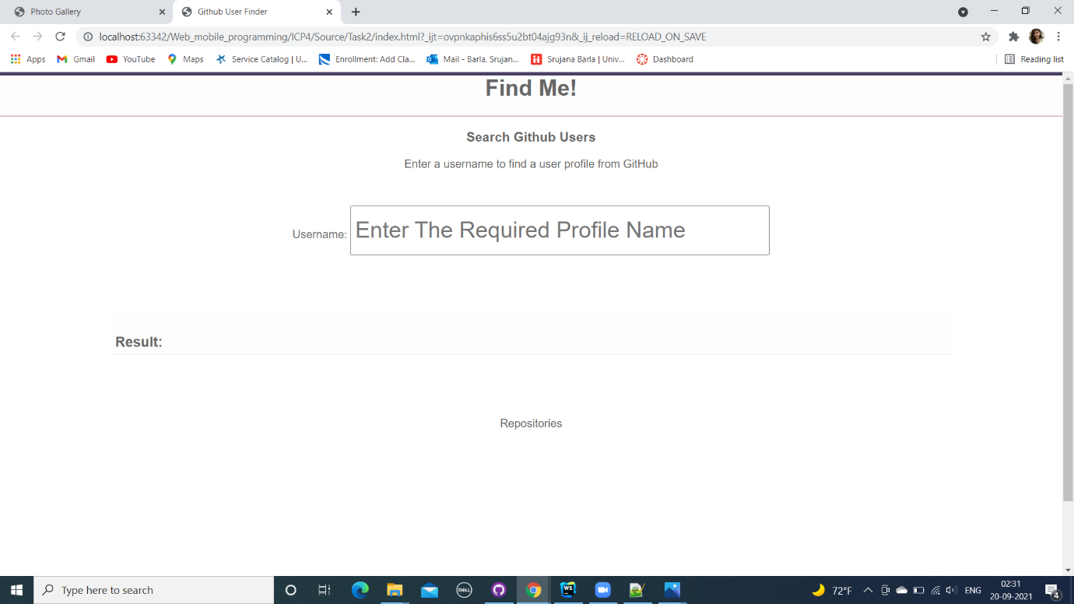

After giving a wrong input in the search bar, it shows like the below result:

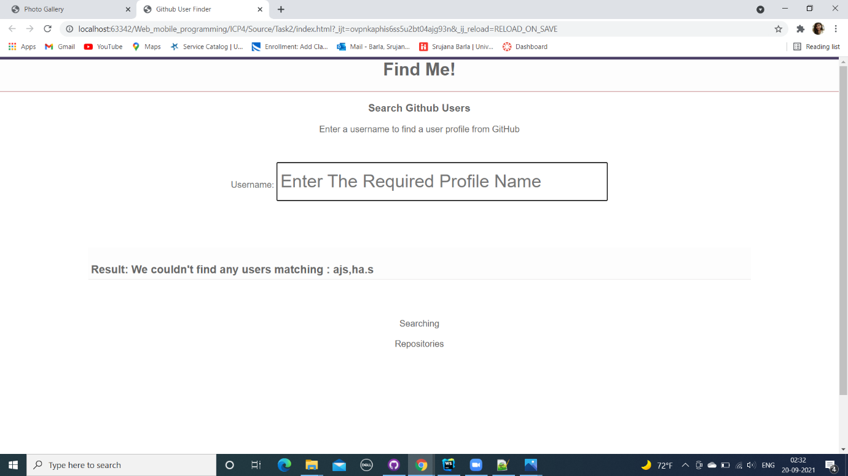

When an existing username is typed , it gives the details of the user like in the below screenshot users 1) Name, 2)ID, 3)Repositories, 4)Name with html link are displayed.

